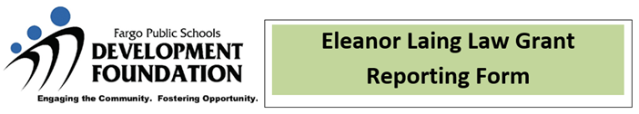

The Fargo Public Schools Development Foundation mission is to partner with the Fargo Public Schools, their alumni, and the greater community to enhance and enrich learning experiences to maximize student potential.

Congratulations on your grant award! To finalize our records, please complete and return this assessment report at the completion of your project or by June 30th of the grant year.

Date: School Name: Click here to select your school

Project Title:

Main Contact Person:

Amount Received: Email:

Phone:

Grant Assessment Details:
(Green boxes will expand as you type.)
Please describe your project. What literacy/library needs did it address? Were there any barriers and/or challenges?
How many were involved in the project? Include educators, students, parents, volunteers, etc. Please be as specific as possible.
What was the most successful part of project?
Did your project collaborate with other groups or receive collaborative funding from with other individuals, schools, or groups? If yes with who and how?
Please share any quotes, comments, photos, etc. from your project that will help us support the Foundation granting process.

Expenses

- All funds for your grant were transferred into an account with the District.
- An email with your expense account number was emailed to you when the grant was awarded. This number should have been used for ordering materials.
- All receipts will be needed for your district account reporting. Original receipts should be submitted to the school district.
- Grant funds that are not used will be returned to the Foundation one year after award was made.
- Equipment purchased with Foundation grant monies is owned by the District and stays at the school where the grant originated. The grant writer has priority use of equipment.

Please summarize how funds were utilized:

Item Description (books, equipment, etc.) | Quantity | Cost/Item | Shipping | Total Cost/Item
Total Cost of Supplies for the Project:

Non-District Personnel Budget (Speakers, authors, artists, etc.)- The Foundation cannot fund district employee salaries or gift cards for reimbursment.) Please contact the HR Department for salary guidelines for positions such as tutors, guest speakers, and other non-district staff.

Who/What Position | Fee or # of Hours | Hourly Rate or Fee | Total Cost
Total Cost of Personnel for the Project:

Other attachments you are submitting, please list:

Submitted by:
(required field)

For questions or more information, contact the Foundation office at 446.1041 or email fpsfound@fargo.k12.nd.us.

Please email the completed grant reporting form to
fpsfound@fargo.k12.nd.us, type Grant Reporting Form in the subject line.

